Day 6 - 29th May 2025

Task 1:

RegEX Symbols in linux
List them down with description
Basic regular expressions
Regular expressions (regex) are powerful tools used for pattern matching in text. They allow you to search, replace, and validate strings efficiently.
- . This basic regular expression replaces any character.
- ^ This basic regular expression matches the start of the string.
- $ This basic regular expression matches the end of the string.
- * This basic regular expression matches up zero or more times the preceding character.
- \ This basic regular expression represents special characters.
- () This basic regular expression groups regular expressions.
- ? This basic regular expression matches up with exactly one character

Task 2:
What are the imp features of Linux os ?
Linux is a powerful and versatile operating system with several key features that make it popular among developers, system administrators, and everyday users. Here are some of its most important features:
- Open-Source – Linux is freely available, and its source code can be modified and distributed by anyone.
- Free to Use – Unlike proprietary operating systems, Linux does not require licensing fees.
- Flexibility – It can be customized extensively, from the kernel to the user interface.
- Stability & Reliability – Linux is known for its robustness and ability to run for long periods without crashing.
- Security – Strong permission management, encryption, and firewall capabilities make Linux highly secure.
- Lightweight – Linux can run on minimal hardware, making it suitable for embedded systems and older machines.
- Multi-User & Multi-Tasking – Multiple users can work on the same system simultaneously, and it efficiently handles multiple processes.
- Shell & Command-Line Interface – Linux provides powerful command-line tools for automation and system management.
- Portability – It can run on various hardware architectures, from personal computers to supercomputers.
- Graphical User Interface (GUI) – While Linux is command-line friendly, it also supports graphical environments like GNOME and KDE.

Task 3:

WHAT IS Kernel and can you explain its features
The kernel is the core component of an operating system that acts as a bridge between hardware and software. It manages system resources like memory, CPU, and input/output devices, ensuring smooth operation.
“Imagine our computer as a big office. The kernel is like the manager of the office. It controls everything to keep things running smoothly.”

Key Features of a Kernel:
🔹 Process Management – The kernel decides which tasks (or "employees") get to use the CPU and for how long. It ensures no task hogs all the resources.
🔹 Memory Management – Think of it as handling office supplies. The kernel makes sure every task gets the right amount of memory and prevents confusion.
🔹 Device Management – It acts as a translator between your computer's software and hardware. When you print a document or use a keyboard, the kernel ensures smooth communication.
🔹 File System Management – Organizes files like a filing cabinet. It handles storing, retrieving, and managing permissions.
🔹 Interprocess Communication (IPC) – Imagine employees exchanging messages. The kernel enables tasks to share data efficiently.
🔹 Security & Access Control – It enforces rules, like passwords and user permissions, ensuring only the right people access sensitive information.
🔹 System Calls & APIs – Think of this as a help desk. The kernel provides ways for applications to request system services.
🔹 Multitasking & Scheduling – It keeps everything balanced, ensuring multiple tasks run smoothly at the same time.
🔹 Interrupt Handling – Like responding to urgent emails, the kernel quickly handles unexpected system events.
🔹 Networking Support – Allows the office (computer) to connect and communicate with others over networks.

Task 4:
What is BASH? Full form with explanation.
BASH stands for Bourne Again SHell. It is a command-line interpreter and scripting language used in Unix-based operating systems like Linux and macOS.
BASH is an improved version of the original Bourne Shell (sh) and is widely used for executing commands, automating tasks, and managing system operations. It allows users to interact with the operating system through a terminal, running commands like ls, cd, and echo.
Key Features
🔹 Command Execution – Runs system commands efficiently.
🔹 Scripting – Automates tasks using shell scripts.
🔹 Variables & Functions – Stores and processes data within scripts.
🔹 Redirection & Piping – Connects commands using > and |.
🔹 Job Control – Manages background and foreground processes.
🔹 History & Aliases – Saves previous commands and allows shortcuts.
🔹 Flow Control – Supports loops and conditional execution.
🔹 Directory Stack – Tracks recently visited directories.
🔹 Restricted Mode – Limits certain commands for security.
🔹 Versatile Invocation – Allows flexible command execution.
BASH is the default shell in most Linux distributions and is essential for system administration and development.
Examples of BASH Usage
1. Running Basic Commands
echo "Hello, World!"
🔹 This prints "Hello, World!" to the terminal.
2. Creating and Using Variables
name="Ajay"
echo "Hello, $name!"
🔹 This stores "Ajay" in a variable and prints "Hello, Ajay!".
3. Using Conditional Statements
num=10
if [ $num -gt 5 ]; then
echo "Number is greater than 5"
else
echo "Number is 5 or less"
fi
🔹 This checks if num is greater than 5 and prints the appropriate message.
4. Looping Through Items
for i in {1..5}; do
echo "Iteration $i"
done
🔹 This prints numbers from 1 to 5.
5. Writing a Simple Script
#!/bin/bash
echo "This is a simple script"
🔹 The #!/bin/bash at the top tells the system to use BASH to execute the script.
Task 5:
What is the difference between window and linux
Windows and Linux are two of the most widely used operating systems, but they differ significantly in their philosophy, design, licensing, and typical use cases. Here's a breakdown of their key differences:
1. Licensing and Source Code:
- Windows: This is a proprietary operating system developed and owned by Microsoft. Its source code is closed-source, meaning users cannot view, modify, or distribute it. We typically need to purchase a license to use Windows.
- Linux: This is an open-source operating system. The Linux kernel (the core) was created by Linus Torvalds, and various distributions (like Ubuntu, Fedora, Debian, Mint) package the kernel with other open-source software. The source code is freely available, allowing users to modify, distribute, and contribute to its development. Most Linux distributions are free to use.
2. Cost:
- Windows: Requires a paid license for installation and use.
- Linux: Generally free to download, install, and use. While some commercial distributions exist that offer paid support, the vast majority are available at no cost.
3. User Interface (UI) and User Experience (UX):
- Windows: Known for its highly polished and standardized graphical user interface (GUI) with a familiar desktop, Start menu, taskbar, and File Explorer. It's designed for ease of use and accessibility for a wide range of users, including those with limited technical knowledge.
- Linux: Offers a wide variety of desktop environments (e.g., GNOME, KDE Plasma, Xfce, LXQt), each with its own distinct look and feel. This allows for immense customization, but can be overwhelming for new users. While many distributions are now very user-friendly, some still have a steeper learning curve, particularly for command-line tasks.
4. Software Availability and Compatibility:
- Windows: Dominates the desktop market, leading to a vast ecosystem of commercial and proprietary software. Many popular applications, especially for gaming, professional creative work (Adobe Creative Suite), and specific business software, are primarily developed for Windows.
- Linux: Has a strong and growing ecosystem of open-source software, including powerful alternatives for many Windows applications (e.g., LibreOffice for Microsoft Office, GIMP for Photoshop, Krita for digital painting). However, some specialized or proprietary Windows applications may not have direct Linux equivalents or may require compatibility layers (like Wine) to run, which can sometimes be unstable.
5. Security:
- Windows: Due to its widespread use, Windows is a more frequent target for malware, viruses, and other cyberattacks. While Microsoft invests heavily in security, its popularity makes it a prime target.
- Linux: Generally considered more secure than Windows. This is partly due to its lower market share (making it less attractive to attackers), its robust permissions system, and the rapid response of its open-source community to identify and patch vulnerabilities. Many servers and critical infrastructure rely on Linux for its security.
6. Stability and Performance:
- Windows: Can sometimes be resource-intensive, especially with many background processes. While modern Windows versions are stable, they can occasionally experience slowdowns or crashes.
- Linux: Often praised for its stability, efficiency, and lower resource requirements. Many Linux distributions can run smoothly on older or less powerful hardware, making them popular for revitalizing old machines or for server environments where uptime and resource efficiency are paramount.
7. Command Line vs. GUI:
- Windows: While it has PowerShell and Command Prompt, most everyday tasks are performed through the GUI.
- Linux: Heavily utilizes the command-line interface (CLI), known as the terminal or shell. While GUIs are present, many advanced tasks, system administration, and development workflows are more efficiently performed using command-line tools. This can be intimidating for beginners but offers immense power and flexibility for experienced users.
8. File System and Path Separators:
- Windows: Uses drive letters (C:, D:, etc.) and backslashes (\) as path separators (e.g., C:\Users\John\Documents). File names are generally case-insensitive.
- Linux: Uses a single, unified file system hierarchy starting from the root directory (/). Forward slashes (/) are used as path separators (e.g., /home/john/documents). File names are case-sensitive (e.g., file.txt and File.txt are considered different).
9. Target Audience and Use Cases:
- Windows: Primarily aimed at general consumers, gamers, and businesses that rely on Microsoft software and a user-friendly, out-of-the-box experience.
- Linux: Favored by developers, system administrators, IT professionals, researchers, privacy-conscious users, and those who desire a high degree of customization and control. It's also the dominant operating system for servers, supercomputers, and embedded devices.
Simple Differences Between Windows and Linux
🔹 Licensing – Windows is proprietary and requires a paid license, while Linux is open-source and free.
🔹 Customization – Linux allows extensive customization, whereas Windows has a standardized interface.
🔹 Security – Linux is generally more secure due to its permission-based system, while Windows is more vulnerable to malware.
🔹 Performance – Linux is lightweight and efficient, while Windows can be resource-intensive.
🔹 Software Compatibility – Windows supports more commercial software, while Linux relies on open-source alternatives.
🔹 Command Line vs GUI – Linux relies heavily on the terminal, while Windows focuses on graphical user interfaces.
🔹 File System – Windows uses drive letters (C:, D:), while Linux has a unified file system starting from /.
🔹 Target Audience – Windows is popular among general users and businesses, while Linux is preferred by developers and system administrators.
Task 6:

Define the basic components of Linux
Linux has several fundamental components that work together to manage system operations efficiently. Here are the basic components:
- Kernel – The core of the operating system that interacts with hardware and manages system resources.
- Shell – A command-line interface that allows users to interact with the system.
- File System – Organizes and manages data storage, ensuring efficient access and retrieval.
- System Libraries – Provide essential functions that allow applications to interact with the kernel.
- System Utilities – Tools and programs that help manage system tasks like file handling, user management, and process control.
- Hardware Layer – Includes physical components like CPU, RAM, and storage devices that the kernel manages.
Task 7:

Is it legal to edit Kernal?
Yes, it is legal to edit the Linux kernel! Linux is released under the GNU General Public License (GPL), which allows users to modify and distribute the kernel freely. However, there are some conditions:
🔹 You can modify the kernel for personal use without restrictions.
🔹 If you distribute your modified version, you must also provide the source code and keep it under the GPL license.
🔹 Credit to original authors must be maintained when sharing modified versions.
This open-source nature is what makes Linux highly customizable and widely used in various industries.
Task 8:

how many of you have gone through techadamy Linux plz raise ur hand
16 pax done out of 29

Can you explain LILO
LILO (Linux Loader) is a bootloader for Linux systems that was widely used before GRUB became the standard. It helps load the Linux kernel into memory and start the operating system.
Key Features of LILO
🔹 Supports Multiple Operating Systems – Can boot Linux alongside other OSes.
🔹 Simple Configuration – Uses a configuration file (/etc/lilo.conf) for setup.
🔹 Fast Booting – Loads the kernel directly from the hard drive.
🔹 Password Protection – Allows securing the boot process with a password.
🔹 Graphical Boot Menu – Displays a menu for selecting the OS to boot.
Although LILO is no longer actively developed, it played a crucial role in Linux's early boot management

Task 9:

What is a shell? How many shells are there and what are they ? Can you explain?
A shell is a command-line interface that allows users to interact with the operating system. It acts as a bridge between the user and the kernel, enabling command execution, scripting, and system management.
Types of Shells in Linux
There are several types of shells, each with unique features:
- Bourne Shell (sh) – The original UNIX shell, known for its simplicity and speed.
- Bourne Again Shell (bash) – An improved version of sh, widely used in Linux.
- C Shell (csh) – Provides C-like syntax and better scripting capabilities.
- Korn Shell (ksh) – Combines features of sh and csh, offering advanced scripting.
- Z Shell (zsh) – An extended version of bash with additional features.
- Tenex C Shell (tcsh) – An enhanced version of csh with better command-line editing.
Task 10:

What is Swap space ?
Swap space is a portion of a hard disk that acts as virtual memory when a system runs out of physical RAM. It temporarily stores inactive memory pages to free up RAM for more critical tasks.
Key Points About Swap Space
🔹 Purpose – Helps prevent system crashes when RAM is full.
🔹 Location – Exists as a dedicated partition or a swap file on the disk.
🔹 Usage – Used when the system needs extra memory beyond available RAM.
🔹 Performance Impact – Excessive swapping can slow down the system due to disk read/write operations.
🔹 Swappiness – A system parameter that controls how aggressively swap space is used.

Task 11:

What is Mount ? How do you mount and unmount a filesystem in Linux?
Mounting in Linux is the process of attaching a file system or storage device (like a USB drive or hard disk partition) to a directory so that its contents can be accessed.
How to Mount a File System?
- Identify the device – Use lsblk or fdisk -l to list available storage devices.
- Create a mount point – Example: sudo mkdir /mnt/mydrive.
- Mount the device – Use sudo mount /dev/sdb1 /mnt/mydrive.
- Verify the mount – Run df -h to check mounted file systems.
How to Unmount a File System?
- Unmount the device – Use sudo umount /mnt/mydrive or sudo umount /dev/sdb1.
- Check if unmounted – Run df -h again to confirm.
- Force unmount (if needed) – Use sudo umount -l /mnt/mydrive if the device is busy.
For automatic mounting at boot, you can configure /etc/fstab.
Task 12:

What is the chmod command ? how to use it?
The chmod command in Linux is used to change file permissions, allowing users to control who can read, write, or execute a file or directory.
How to Use chmod
- Check Current Permissions :
ls -l filename : Displays the file's current permissions
- Change Permissions Using Symbolic Mode :
chmod u+r filename # Give read permission to the owner
chmod g-w filename # Remove write permission from the group
chmod o+x filename # Allow others to execute the file

Task 13:

Can you add a new user account? Create a new user in different ways and paste ss

Yes, We can add a new user account in Linux using different methods. Here are the most common ways:
1. Using useradd Command :
sudo useradd -m -s /bin/bash newuser
sudo passwd newuser
🔹 -m creates a home directory, -s sets the default shell, and passwd sets a password
2. Using adduser Command
sudo adduser newuser
🔹 This prompts for user details and automatically sets up a home directory
3. Creating a User with Custom UID/GID
sudo useradd -u 1050 -g 1000 newuser
🔹 Assigns a custom User ID (UID) and Group ID (GID)
4. Creating a User Without a Home Directory
sudo useradd -M newuser
🔹 Useful for system accounts that don’t need a home directory
5. Checking If User Was Created
cat /etc/passwd | grep newuser
🔹 Displays user details from the system
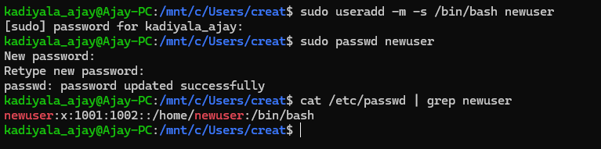

Task 14:

Can you change the password of a user?
How do you do that? Plz share ss
Yes! We can change a user's password in Linux using the passwd command.
1. Change Your Own Password
passwd # prompted to enter your current password, then a new one

2. Change Another User’s Password (Requires Root Privileges)
sudo passwd username

3. Force a User to Change Password at Next Login
sudo passwd --expire username # The user will be required to set a new password upon login

4. Check Password Status
sudo passwd -S username # Displays password details like last change date and expiration

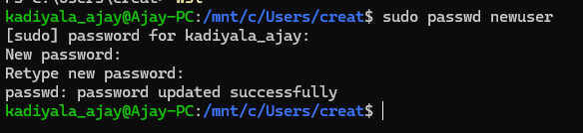

Task 15:

What is the difference between Process and Thread?
- Process – A program in execution, with its own memory space and resources.
- Thread – A lightweight unit within a process that shares memory and resources with other threads.
Key Differences
- Memory – Processes have separate memory, while threads share memory within a process.
- Execution – A process runs independently, while threads within a process run concurrently.
- Communication – Inter-process communication (IPC) is needed for processes, while threads communicate easily.
- Context Switching – Processes require more time for switching, while threads switch faster.
- Resource Consumption – Processes consume more resources, while threads are efficient.
A thread exists inside a process, not the other way around.
- A process is an independent program in execution, with its own memory and resources.
- A thread is a smaller unit within a process that shares memory and resources with other threads in the same process.
- A process can have multiple threads, but a thread cannot exist outside a process.

Task 16:
Doc 14 Linux Grep commands .. plz work on it..

Syntax of grep Command in Unix/Linux:
The basic syntax of the `grep` command is as follows:
grep [options] pattern [files]
- [options]: These are command-line flags that modify the behavior of grep.
- [pattern]: This is the regular expression you want to search for.
- [file]: This is the name of the file(s) you want to search within. You can specify multiple files for simultaneous searching.
Options Available in grep Command

Options | Description
-c | This prints only a count of the lines that match a pattern
-h | Display the matched lines, but do not display the filenames.
-i | Ignores, case for matching
-l | Displays list of a filenames only.
-n | Display the matched lines and their line numbers.
-v | This prints out all the lines that do not matches the pattern
-e exp | Specifies expression with this option. Can use multiple times.
-f file | Takes patterns from file, one per line.
-E | Treats pattern as an extended regular expression (ERE)
-w | Match whole word
-o | Print only the matched parts of a matching line, with each such part on a separate output line.
-A n | Prints searched line and nlines after the result.
-B n | Prints searched line and n line before the result.
-C n | Prints searched line and n lines after before the result.

Sample Commands
Consider the below file as an input.
cat > hellofile.txt
unix is great os. unix was developed in Bell labs.
learn operating system.
Unix linux which one you choose.
uNix is easy to learn.unix is a multiuser os.Learn unix .unix is powerful.
Practical Example of grep Command in Linux
1. Case insensitive search
The -i option enables one to search for a string case insensitively in the given file. It matches words like "UNIX", "Unix", "unix".
grep -i "UNix" hellofile.txt
Output:
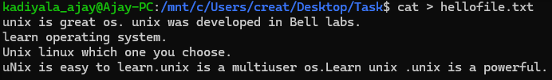
“Case insensitive search”
2. Displaying the Count of Number of Matches Using grep
We can find the number of lines that matches the given string/pattern
grep -c "unix" hellofile.txt
Output:
“Displaying the count number of the matches”

3. Display the File Names that Matches the Pattern Using grep
We can just display the files that contain the given string/pattern.
grep -l "unix" *
or
grep -l "unix" f1.txt f2.txt f3.xt f4.txt
Output:
“The filename that matches the pattern”

4. Checking for the Whole Words in a File Using grep
By default, grep matches the given string/pattern even if it is found as a substring in a file. The -w option to grep makes it match only the whole word.
grep -w "unix" hellofile.txt
Output:
“checking whole words in a file”
5. Displaying only the matched pattern Using grep
By default, grep displays the entire line which has the matched string. We can make the grep to display only the matched string by using the -o option.
grep -o "unix" hellofile.txt
Output:
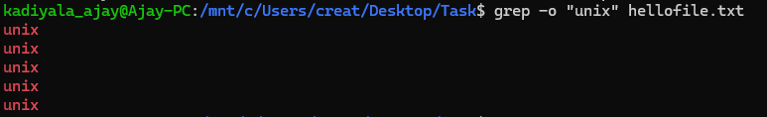
“Displaying only the matched pattern”
6. Show Line Number While Displaying the Output Using grep -n
To show the line number of file with the line matched.
grep -n "unix" hellofile.txt
Output:
“Show line number while displaying the output”
7. Inverting the Pattern Match Using grep
You can display the lines that are not matched with the specified search string pattern using the -v option.
grep -v "unix" hellofile.txt
Output:
“Inverting the pattern match”
8. Matching the Lines that Start with a String Using grep
The ^ regular expression pattern specifies the start of a line. This can be used in grep to match the lines which start with the given string or pattern.
grep "^unix" hellofile.txt
Output:
“Matching the lines that start with a string”
9. Matching the Lines that End with a String Using grep
The $ regular expression pattern specifies the end of a line. This can be used in grep to match the lines which end with the given string or pattern.
grep "os$" hellofile.txt
Output:
10.Specifies expression with -e option
Can use multiple times :
grep –e "Agarwal" –e "Aggarwal" –e "Agrawal" hellofile.txt
Output:
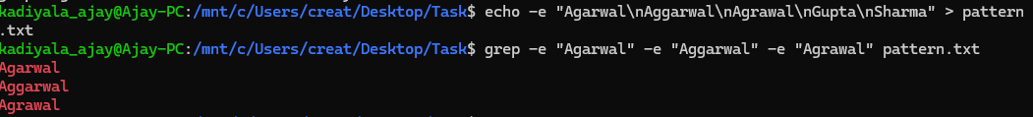
11. -f file option Takes patterns from file, one per line
cat pattern.txt
Agarwal
Aggarwal
Agrawal
grep –f pattern.txt hellofile.txt
Output: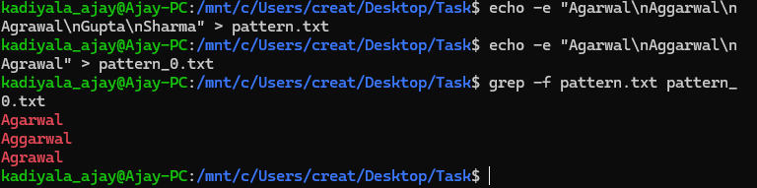

12. Print n Specific Lines from a File Using grep
-A prints the searched line and n lines after the result, -B prints the searched line and n lines before the result, and -C prints the searched line and n lines after and before the result.
Syntax:
grep -A[NumberOfLines(n)] [search] [file]
grep -B[NumberOfLines(n)] [search] [file]
grep -C[NumberOfLines(n)] [search] [file]
Example:
grep -A1 learn hellofile.txt
Output:
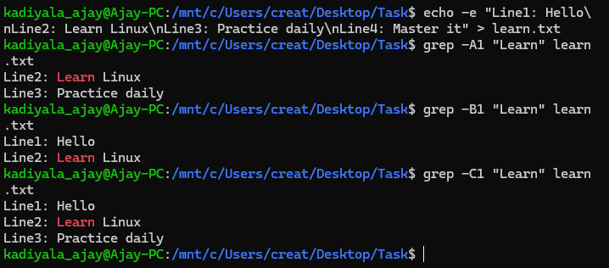
“Print n specific lines from a file”

13. Search Recursively for a Pattern in the Directory
-R prints the searched pattern in the given directory recursively in all the files.
Syntax:
grep -R [Search] [directory]
Example :
grep -iR hellos /home/hellos
./hellos2.txt:Well Hello hellos
./hellos1.txt:I am a big time hello
----------------------------------
-i to search for a string case insensitively
-R to recursively check all the files in the directory.

Output:
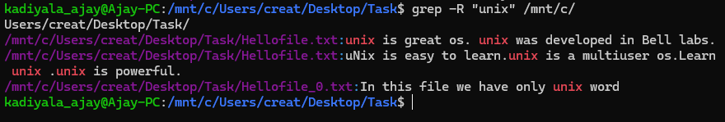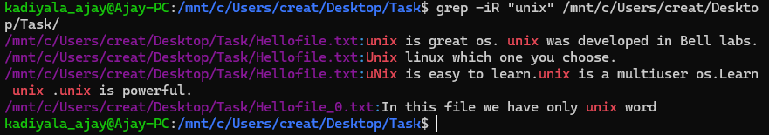

What is AWK Command in Linux?
AWK is a programming language and tool that is used for text processing and data manipulation. It is typically used for extracting and manipulating data from text files, but it can also be used for more complex tasks such as generating reports, analyzing data and more. AWK is available on almost all Unix-based systems and is often used in conjunction with other command-line tools such as sed and grep.

AWK Command Syntax
The AWK command has a simple syntax that consists of a series of patterns and actions. Patterns are used to match specific lines of input, while actions are used to specify what should be done with those lines. Here is an example of basic syntax of AWK command ?
awk 'pattern { action }' input_file

The pattern is enclosed in single quotes and specifies which lines of the input file should be processed. action is enclosed in curly braces and specifies what should be done with those lines. Multiple patterns and actions can be combined to create more complex scripts.

AWK Command Functions
AWK has a variety of built-in functions that can be used to manipulate and process data. Here are some of the most commonly used functions ?
- print ? This function is used to print text to console or a file.
- printf ? This function is used to format text and print it to console or a file.
- length ? This function is used to determine the length of a string.
- substr ? This function is used to extract a substring from a string.
- split ? This function is used to split a string into an array based on a specified delimiter.
- getline ? This function is used to read the next line of input.
Examples for commonly used functions:
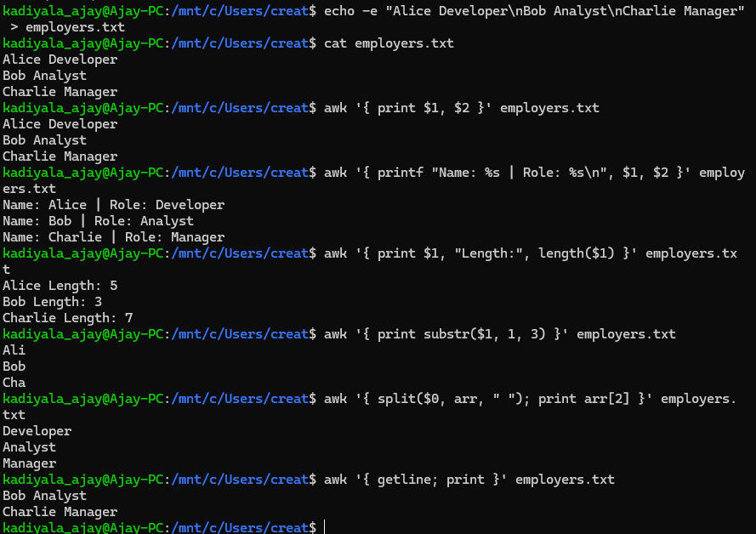

AWK Command Examples
Now that we understand basic syntax and functions of AWK command, let's look at some examples of how it can be used.

Example 1: Print Contents of a File
The simplest use of AWK command is to print the contents of a file to the console. Here's how to do it ?
awk '{ print }' input_file #This script will match every line in the input file and print it to the console.
Output: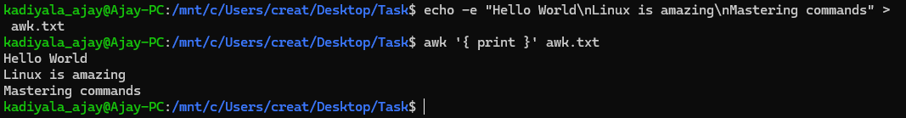

Example 2: Print Specific Columns of a File
One of the most common uses of AWK is to extract specific columns from a file. Here's how to extract the first and third columns of a file ?
awk '{ print $1, $3 }' input_file
Output:
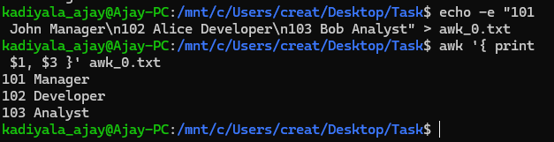
This script will match every line in the input file and print first and third columns to console.

Example 3: Filter Lines Based on a Condition
AWK can also be used to filter lines based on a condition. Here's how to print all lines in a file that contain the word "error" ?
awk '/error/ { print }' input_file
Output: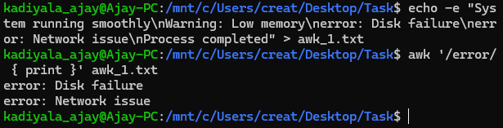This script will match every line in the input file that contains the word "error" and print it to the console.

Example 4: Sum Values in a Column
AWK can also be used to perform mathematical operations on data. Here's how to sum values in the second column of a file ?
awk '{ sum += $2 } END { print sum }' input_file
Output:
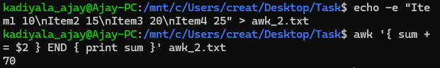This script will add up all values in the second column of input file and print total to console.

Example 5: Extract Substring from a Column
Another common task is to extract a substring from a column in a file. Here's how to extract the first three characters from the first column of a file ?
awk '{ print substr($1, 1, 3) }' input_file
Output:
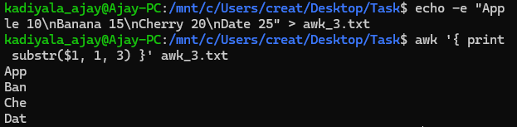This script will extract the first three characters from the first column of the input file and print them to console.

Example 6: Join Two Files Based on a Common Column
AWK can also be used to join two files based on a common column. Here's how to join two files based on the value of the first column ?
awk 'NR==FNR{a[$1]=$2;next}{ print $0, a[$1] }' file1 file2

Output:
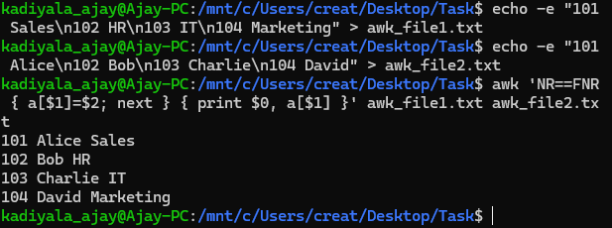This script will read the first file into memory and create an array with values in the second column. It will then read the second file and print each line, followed by the corresponding value from the first file.

Example 7: Extract First Column of a File
To extract the first column of a file using AWK command, use the following syntax ?
$ awk '{ print $1 }' filename
Output:
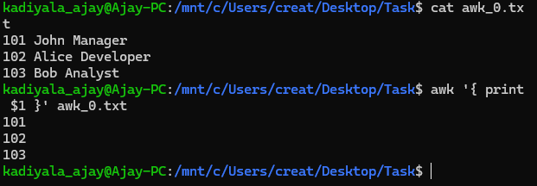Here, $1 refers to the first column of the input file. print command is used to display output.

Example 8: Calculate Average of a Column
To calculate the average of a column using AWK command, use the following syntax ?
$ awk '{ sum += $1 } END { print sum / NR }' filename
Output:
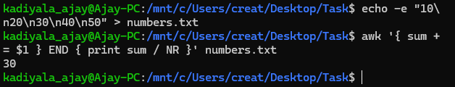Here, sum is a variable that stores the sum of values in the first column. NR is a built-in variable that stores the number of records (lines) processed by AWK command. END pattern matches end of input file.

Example 9: Replace a String in a File
To replace a string in a file using AWK command, use the following syntax ?
$ awk '{ gsub("oldstring", "newstring") } 1' filename
Output:
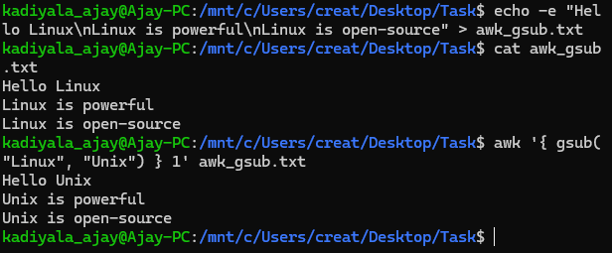Here, gsub is a function that replaces all occurrences of oldstring with newstring. 1 pattern matches all lines of the input file.

Example 10: Display Last Field of a File
To display the last field of a file using AWK command, use the following syntax ?
$ awk '{ print $NF }' filename
Output:
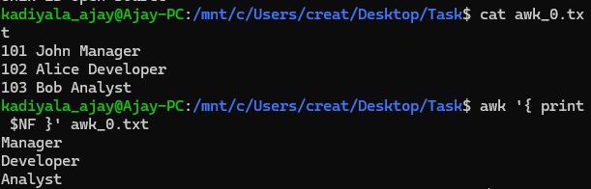Here, $NF refers to the last field of the input file. print command is used to display output.

Example 11: Using Regular Expressions
Regular expressions are a powerful feature of AWK commands that allows users to search for patterns in data. Here's an example that demonstrates use of regular expressions ?
$ awk '/pattern/ { print }' filename
Output:
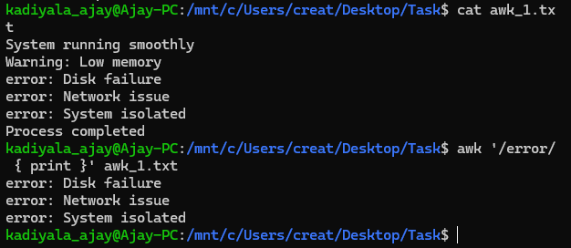Here, /pattern/ is a regular expression that matches any line that contains a pattern.

Example 12: Using Variables
Variables can be used in AWK commands to store values that can be used in actions. Here's an example that demonstrates use of variables ?
$ awk '{ total += $1 } END { print "Total: ", total }' filename
Output:
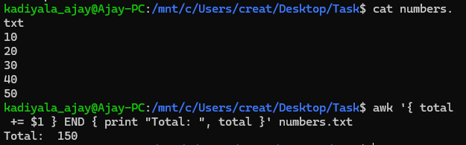Here, variable total is used to store the sum of values in the first column.

Example 13: Using Built-in Variables
The AWK command has several built-in variables that can be used to perform various tasks. Here are some examples ?
- FS ? field separator variable is used to specify delimiter used to separate fields in input file. By default, it is set to whitespace.
- RS ? record separator variable is used to specify delimiter used to separate records in input file. By default, it is set to a newline character.
- OFS ? output field separator variable is used to specify delimiter used to separate fields in output. By default, it is set to whitespace.
- ORS ? output record separator variable is used to specify delimiter used to separate records in output. By default, it is set to a newline character.

Example 14: Using Control Statements
Control statements such as if-else and while loops can be used in AWK command to perform conditional operations. Here's an example that demonstrates use of if-else statements ?
$ awk '{ if ($1 > 50) { print "Pass" } else { print "Fail" } }' filename

Output:
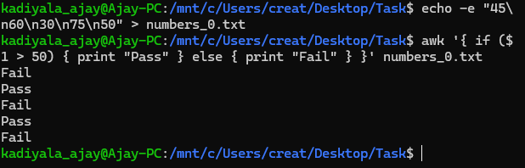Here, if the value in the first column is greater than 50, output will be "Pass," otherwise it will be "Fail."

Example 15: Using Functions
Functions can be defined and used in AWK command to perform complex operations. Here's an example that demonstrates use of functions ?
$ awk 'function square(x) { return x*x } { print square($1) }' filename
Output: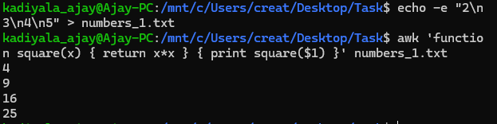
Here, function square is defined and used to calculate square of value in first column

Task 19:

What are the default permissions for a new file ?

Plz find out for
Owner → ?
Group → ?
All and others → ?
Here for a new file hellofile.txt by using the ls -l hellofile.txt we can see the output

-rwxrwxrwx 1 kadiyala_ajay kadiyala_ajay 182 May 29 08:57 hellofile.txt

User Type | Permission
Owner | Read & Write (rw-)
Group | Read & Write (rw-)
Others | Read & Write (rw-)

Task 20:

What is the command to change the permission to read only for the owner, group and all other users

HInt: chmod 444 filename
Output:
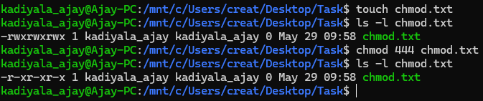

Task 21:

Can you change the file permissions to match the following:
- owner: Read and Write
- group: Read
- other: no permissions (None)
Output:
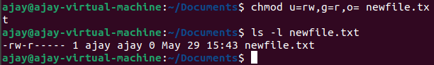
Task 22:
What was the command for changing the file permissions to -rw-r-----?
Hint : use chmod 640 filename
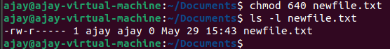
Task 23:
Change chmod.exercises permissions to -rwxr-x--x
Change the file permissions to match the following:
owner: Read, Write and Execute
group: Read and Execute
other: Execute
Output:
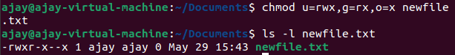
Task 24:
What was the command for changing the file permissions to -rwxr-x--x
Hint : use chmod 751 filename
Output:
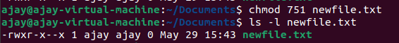
Task 25:
Guys what will this command do?
chown -c master file1.txt
The command chown -c master file1.txt attempts to change the ownership of file1.txt to the user master, while using the -c option to display a message only if a change occurs.
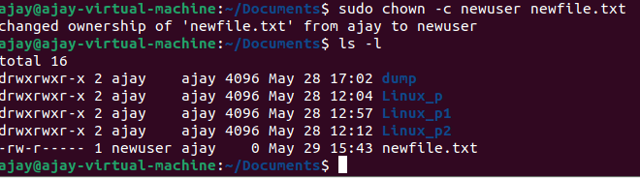

Processes 👍
Task 26:
Can you define what a process is?
A process is an instance of a program that is currently running on a computer. It includes the program code, allocated system resources, and execution state. Processes can be foreground (interactive) or background (running without user interaction).
Task 27:
What is command to check foreground process and background process
Foreground Processes: ps command
Background Processes: jobs command
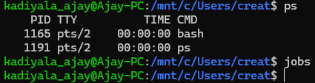
Task 28:
Can you list all the running processes?
Hint use ps
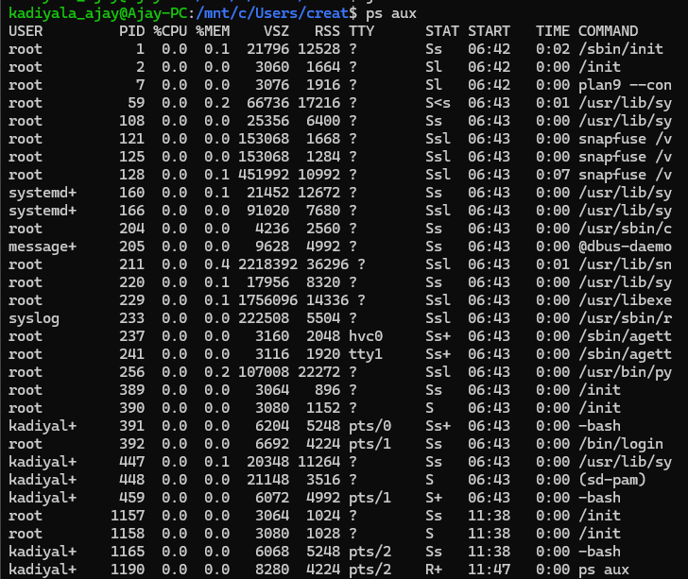

Task 29:
What will ps -f command do ? plz try n check .. ss required.
The ps -f command in Linux provides a full-format listing of processes, displaying detailed information such as:
- UID (User ID)
- PID (Process ID)
- PPID (Parent Process ID)
- C (CPU utilization)
- STIME (Start time)
- TTY (Terminal)
- TIME (CPU time used)
- CMD (Command that started the process)
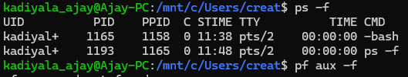

Lets play with shell variables
Task 30:
Can you create a variable name with your name in it
Ex:
Name = “Ajay Kumar”
Id = 10001
And check
Echo $Name
Check the output
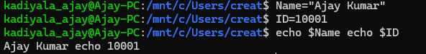
Task 31:
Can you make the above name variable read only..
Ex:
Name = “Ajay Kumar”
Readonly Name
Name = “Jay” —>what will this display.. Is it saying read only?? Pl check
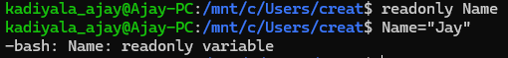
Task 32:
Now will unset or delete the variables
Use the below command and check
Unset Name
Now check for
echo $Name —> this should not print anything.. Plz try also specify the reason
Output:
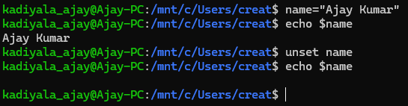
Read and Know that
Variable Types
When a shell is running, three main types of variables are present −
Local Variables − A local variable is a variable that is present within the current instance of the shell. It is not available to programs that are started by the shell. They are set at the command prompt.
Environment Variables − An environment variable is available to any child process of the shell. Some programs need environment variables in order to function correctly. Usually, a shell script defines only those environment variables that are needed by the programs that it runs.
Shell Variables − A shell variable is a special variable that is set by the shell and is required by the shell in order to function correctly. Some of these variables are environment variables whereas others are local variables.

Task 33:

Can u try to add a list of your friends names in an array and try to printout
Ex:
NAME[0]="Ram"
NAME[1]="Sita"
NAME[2]="Tina"
NAME[3]="Veena"
NAME[4]="Tim"
echo "First Index: ${NAME[0]}"
echo "Second Index: ${NAME[1]}"
Output:
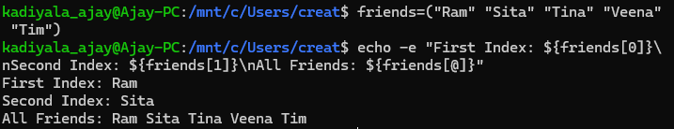
Task 34:
Can you print all the list at once in an array.. Try the below cmds and check
Echo “${array_name[*]}”
Echo “${array_name[@]}”
Output:
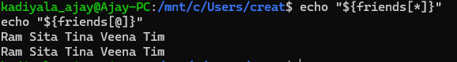

Operators 👍
Operators
- Arithmetic Operators: Perform mathematical operations (+, -, *, /, %, **).
- Relational Operators: Compare values (-eq, -ne, -gt, -lt, -ge, -le).
- Boolean Operators: Logical operations (!, -o, -a).
- String Operators: String comparisons (=, !=, -z, -n).
- File Test Operators: Check file properties (-f, -d, -r, -w, -x, -s, -e).
Conditional Statements
- if...fi: Executes a block if a condition is true.
- if...else...fi: Adds an alternative block if the condition is false.
- if...elif...else...fi: Allows multiple conditions.
- case...esac: Used for multi-way branching, similar to switch in other languages.
Loops
- while loop: Runs while a condition is true.
- for loop: Iterates over a list of values.
- until loop: Runs until a condition becomes true.
- select loop: Creates a menu for user selection.
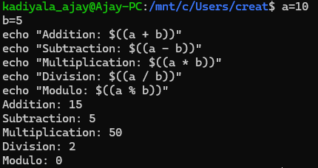
Examples:
1. Arithmetic Operators:

2. Relational Operators:
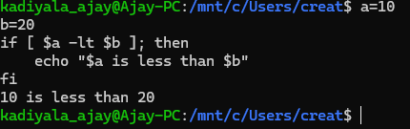
3. Boolean Operators
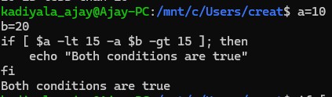
4. String Operators
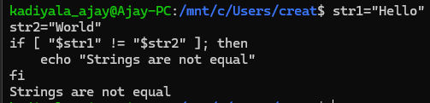
5. File Test Operators
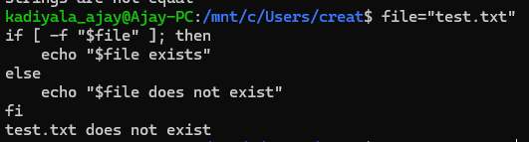
Conditional Statements
1. if...fi Statement
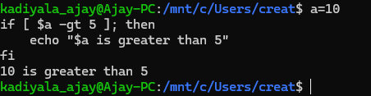
2. if...else...fi Statement
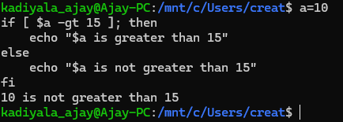
3. if...elif...else...fi Statement
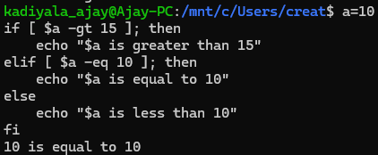
4. case...esac Statement
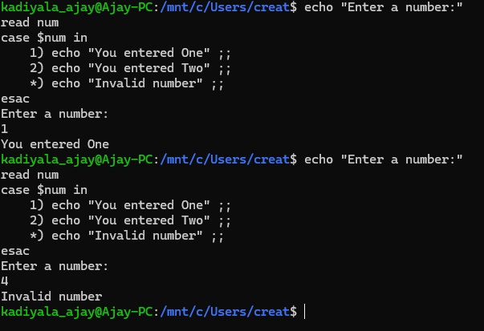
Loops in Shell Scripting
1. while Loop
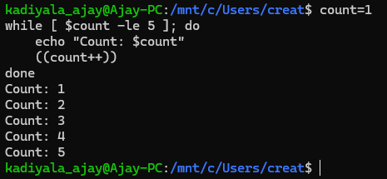
2. for Loop
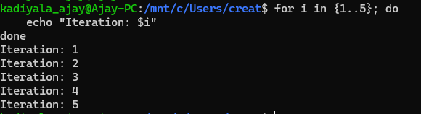
3. until Loop
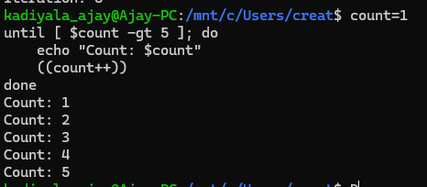

4. select Loop
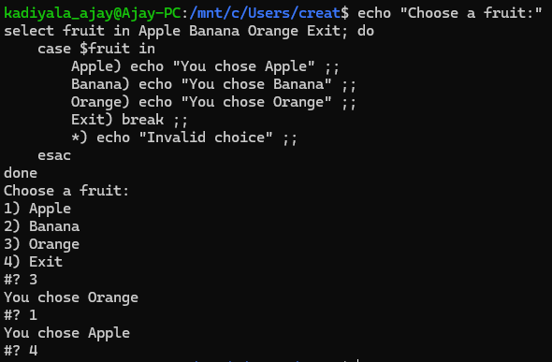

Task 35:
Plz let me know what's the output of the below snippet:
a=0
while [ "$a" -lt 10 ] # this is loop1
do
b="$a"
while [ "$b" -ge 0 ] # this is loop2
do
echo -n "$b "
b=`expr $b - 1`
done
echo
a=`expr $a + 1`
Done
Output:
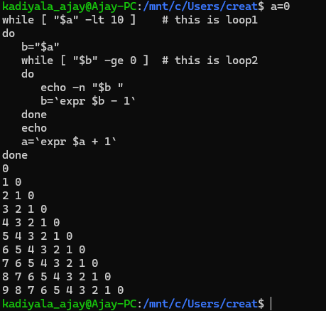
Add ons:
—----------------------------------------------------------------------------------------------------------

Stopping Processes
Ending a process can be done in several different ways. Often, from a console-based command, sending a CTRL &plus; C keystroke (the default interrupt character) will exit the command. This works when the process is running in the foreground mode.
If a process is running in the background, you should get its Job ID using the ps command. After that, you can use the kill command to kill the process as follows −
$ps -f
UID PID PPID C STIME TTY TIME CMD
amrood 6738 3662 0 10:23:03 pts/6 0:00 first_one
amrood 6739 3662 0 10:22:54 pts/6 0:00 second_one
amrood 3662 3657 0 08:10:53 pts/6 0:00 -ksh
amrood 6892 3662 4 10:51:50 pts/6 0:00 ps -f
$kill 6738
Terminated

Here, the kill command terminates the first_one process. If a process ignores a regular kill command, you can use kill -9 followed by the process ID as follows −
$kill -9 6738
Terminated

Parent and Child Processes
Each unix process has two ID numbers assigned to it: The Process ID (pid) and the Parent process ID (ppid). Each user process in the system has a parent process.
Most of the commands that you run have the shell as their parent. Check the ps -f example where this command listed both the process ID and the parent process ID.

Zombie and Orphan Processes
Normally, when a child process is killed, the parent process is updated via a SIGCHLD signal. Then the parent can do some other task or restart a new child as needed. However, sometimes the parent process is killed before its child is killed. In this case, the "parent of all processes," the init process, becomes the new PPID (parent process ID). In some cases, these processes are called orphan processes.
When a process is killed, a ps listing may still show the process with a Z state. This is a zombie or defunct process. The process is dead and not being used. These processes are different from the orphan processes. They have completed execution but still find an entry in the process table.

Daemon Processes
Daemons are system-related background processes that often run with the permissions of root and services requests from other processes.
A daemon has no controlling terminal. It cannot open /dev/tty. If you do a "ps -ef" and look at the tty field, all daemons will have a ? for the tty.
To be precise, a daemon is a process that runs in the background, usually waiting for something to happen that it is capable of working with. For example, a printer daemon waiting for print commands.
If you have a program that calls for lengthy processing, then its worth to make it a daemon and run it in the background.

The top Command
The top command is a very useful tool for quickly showing processes sorted by various criteria.
It is an interactive diagnostic tool that updates frequently and shows information about physical and virtual memory, CPU usage, load averages, and your busy processes.
Here is the simple syntax to run top command and to see the statistics of CPU utilization by different processes −
$top

Job ID Versus Process ID
Background and suspended processes are usually manipulated via job number (job ID). This number is different from the process ID and is used because it is shorter.
In addition, a job can consist of multiple processes running in a series or at the same time, in parallel. Using the job ID is easier than tracking individual processes.

—-------------------------------------------------------------------------------

